CS 255 System Design Document Template

UML Diagrams

UML Use Case Diagram
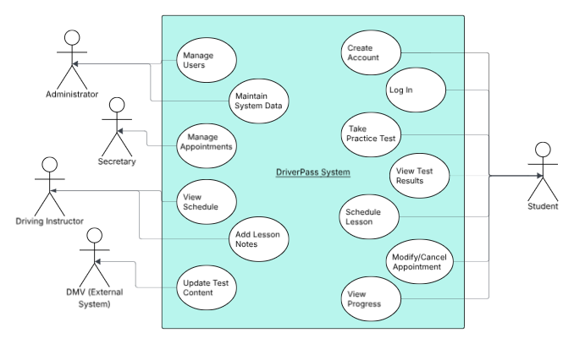

UML Activity Diagrams

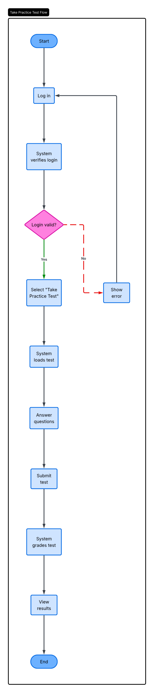

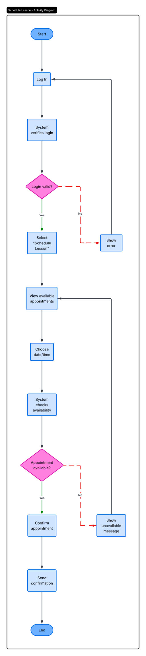

UML Sequence Diagram

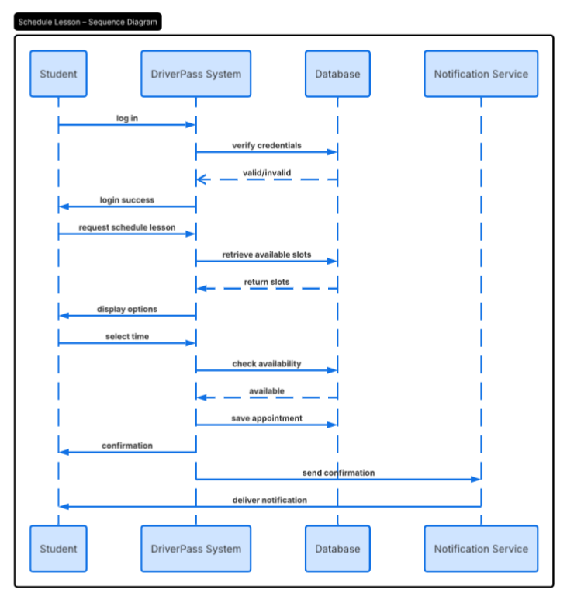

UML Class Diagram

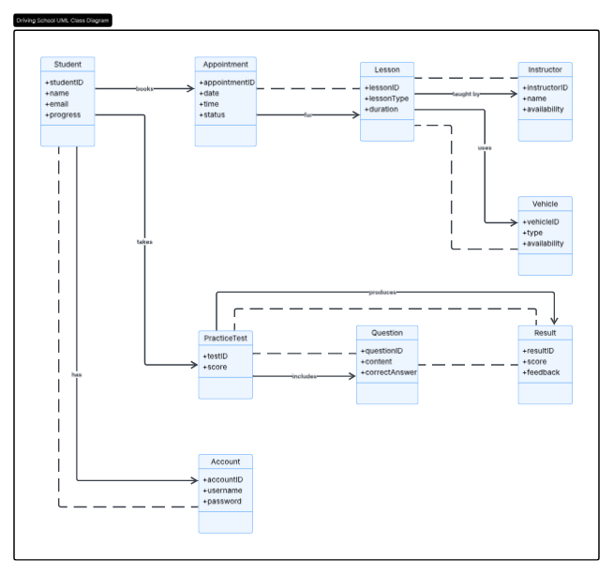

Technical Requirements

The DriverPass system will require both hardware and software components to function effectively. On the hardware side, users will need access to a computer, tablet, or smartphone with an internet connection. The system will be web-based, so no specialized hardware will be required beyond a device capable of running a modern web browser. The system will also require server infrastructure to handle user requests, store data, and manage application performance.

On the software side, the system will operate through a web browser and will be supported by a backend server that processes user actions such as scheduling lessons and taking practice tests. A database management system will be used to store user accounts, appointment data, test questions, and results. The system should also include secure authentication features to protect user information and ensure that only authorized users can access their accounts.
In terms of tools and infrastructure, the system will rely on cloud-based hosting to provide scalability and reliability. This will allow the system to handle multiple users at the same time without performance issues. Security measures such as encryption and role-based access control will be implemented to protect sensitive data. Additionally, the system will include a notification service to send confirmations and updates to users regarding their scheduled lessons and test results.

